1.

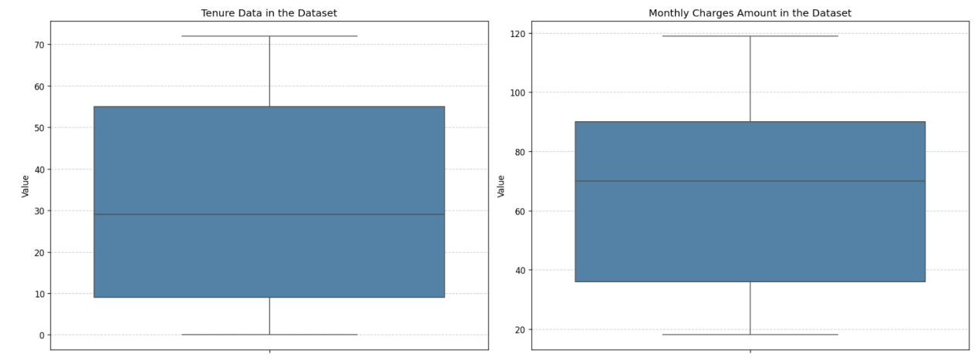

The left boxplot shows the distribution of customer tenure. Most users stay between 0 and 72 months, with a median around 30 months. A few outliers suggest some customers have unusually short or long durations.

The right boxplot represents monthly charges. The median charge is around $70. While most customers pay between $20 and $120, some outliers indicate higher monthly charges. The right-skewed shape suggests a small group of high-paying users.

2.

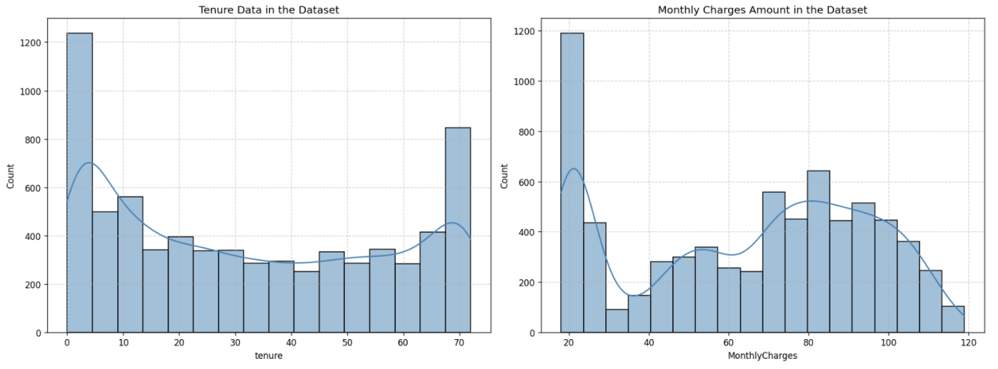

The left histogram shows the distribution of customer tenure. It reveals that many customers are either very new (close to 0 months) or have been with the company for a long time (close to 70 months), suggesting a mix of short-term and loyal long-term users.

The right histogram presents the distribution of monthly charges. It is more spread out, with a notable number of customers paying either low (< $30) or high (> $90) monthly charges, indicating pricing diversity among customers.

3.

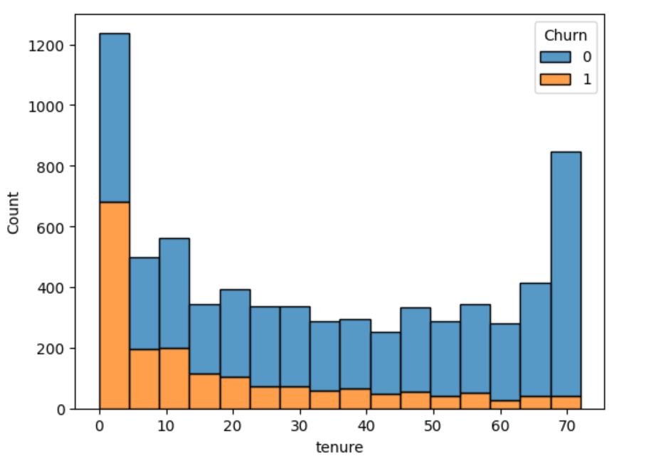

This chart shows that customers who joined recently (less than 10 months) are more likely to leave. As customers stay longer, they are less likely to churn. People who have used the service for more than 60 months almost never leave. This means the company should take better care of new customers to stop them from leaving early.

4.

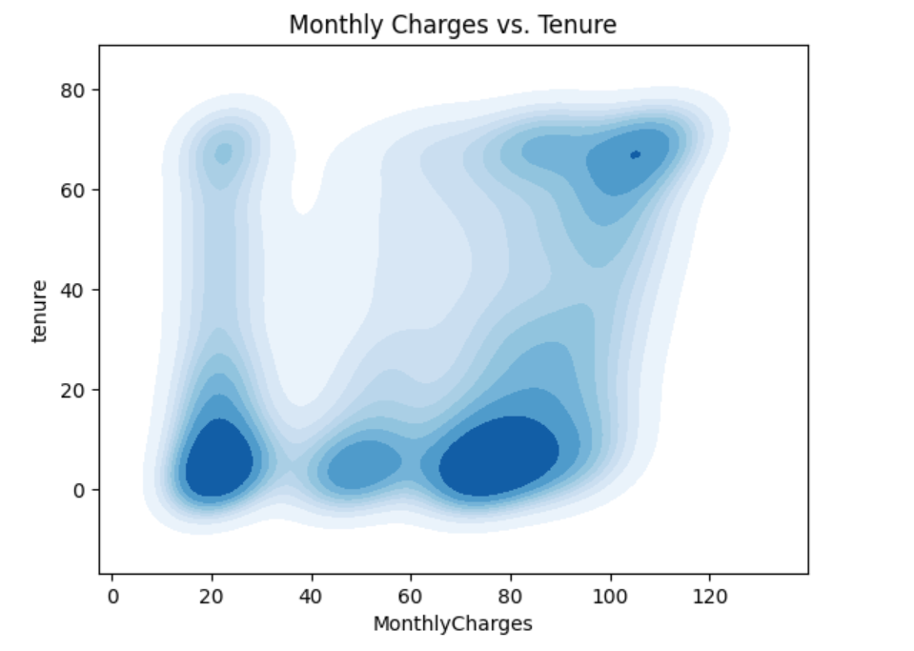

This plot shows the relationship between monthly charges and customer tenure. We can see that there are two main groups: one with low tenure and a wide range of charges, and another with long tenure and high charges. This means new users may have different pricing plans, while long-term users usually pay more each month.

5.

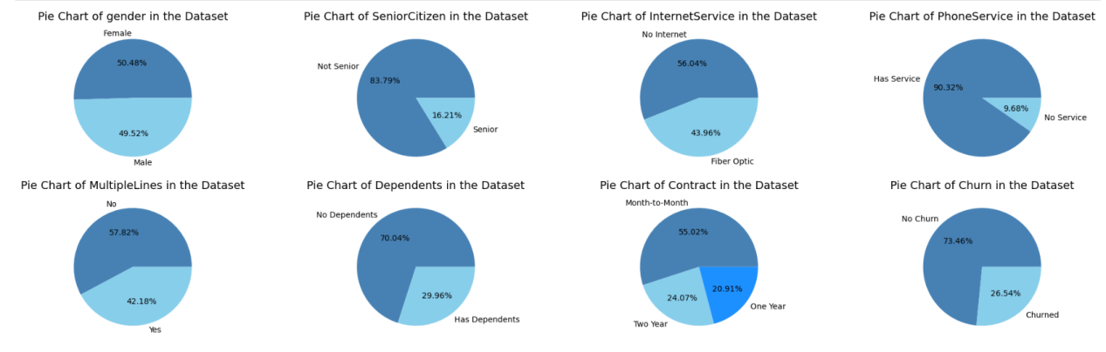

These pie charts show the distribution of key categorical features in the dataset. The gender and churn distributions are fairly balanced. Most customers are not senior citizens (83.79%) and have phone service (90.32%). Over half do not have internet service or dependents. Contract types are mostly month-to-month (55.02%), which may be linked to the higher churn rate (26.54%).

6.

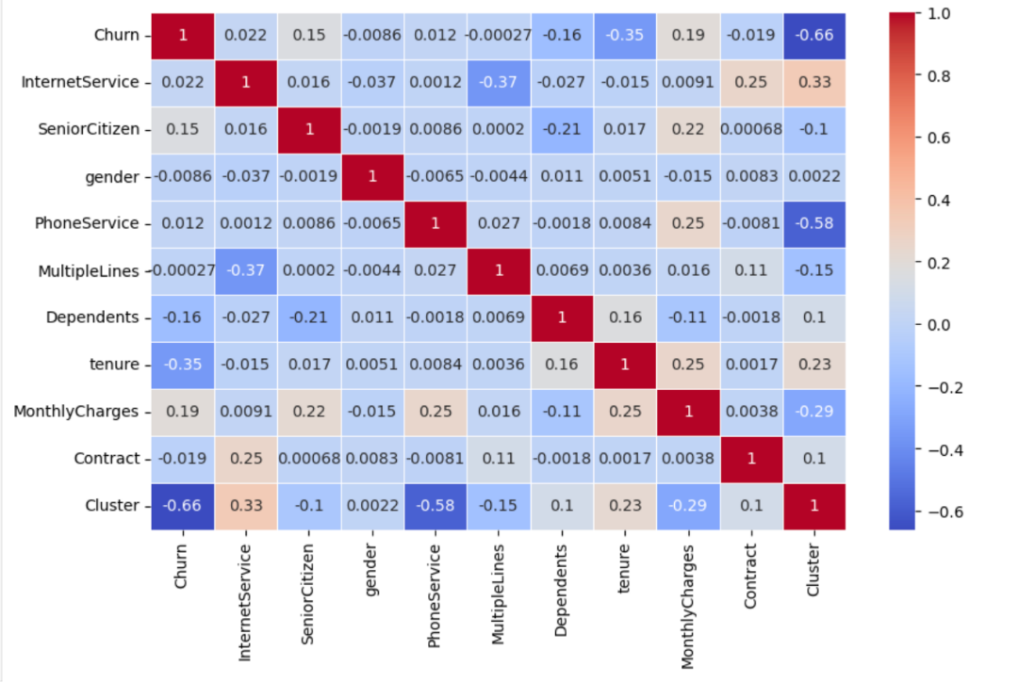

The heatmap shows the correlation between all numerical features. Churn is negatively correlated with tenure (–0.35) and having dependents (–0.16), indicating that customers who stay longer or have dependents are less likely to churn. The strongest negative correlation with churn is from the cluster label (–0.66), suggesting the clustering model effectively separated churn-prone customers.

7.

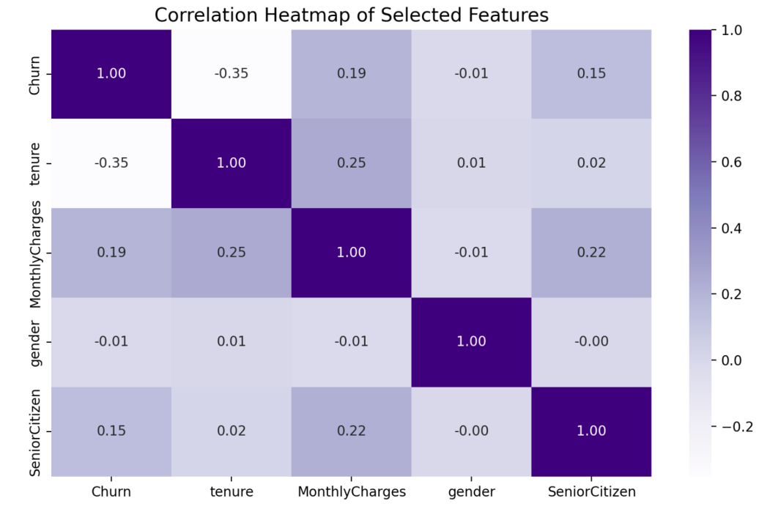

This heatmap focuses on key features. Churn is negatively correlated with tenure (–0.35), meaning customers who stay longer are less likely to leave. Monthly charges show a small positive correlation with churn (0.19), suggesting higher bills may slightly increase churn. Gender and senior citizen status show weak or no clear relationship with churn.

8.

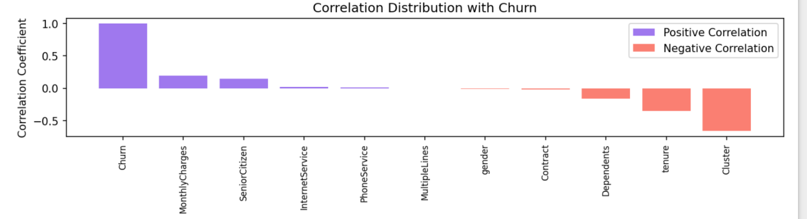

This bar chart shows how different features relate to churn. Features like MonthlyCharges and SeniorCitizen have a weak positive correlation, meaning they slightly increase churn. On the other hand, tenure, Dependents, and Contract have negative correlations, meaning customers who stay longer, have dependents, or longer contracts are less likely to leave. Cluster has the strongest negative correlation, showing that clustering helps group users with different churn risks.

9.

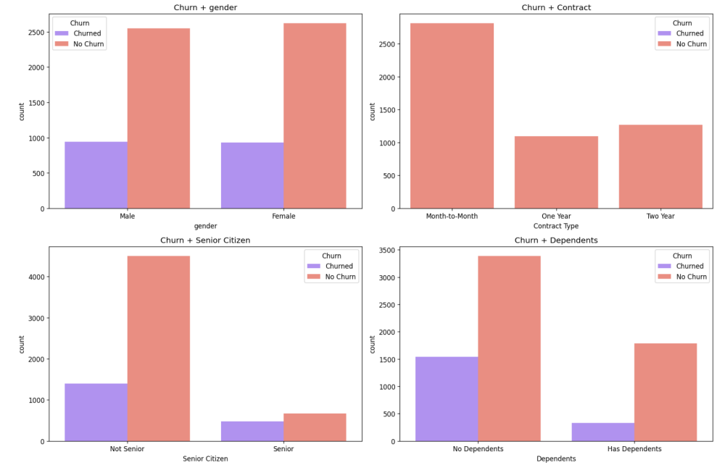

These charts show how different user attributes relate to churn.

Gender: Both males and females have similar churn rates. Gender doesn't strongly affect churn. Contract Type: Customers with Month-to-Month contracts churn more, while those with One Year or Two Year contracts churn less. Senior Citizen: Senior users churn more than younger users. Dependents: Customers with no dependents are more likely to churn compared to those with dependents.

10.

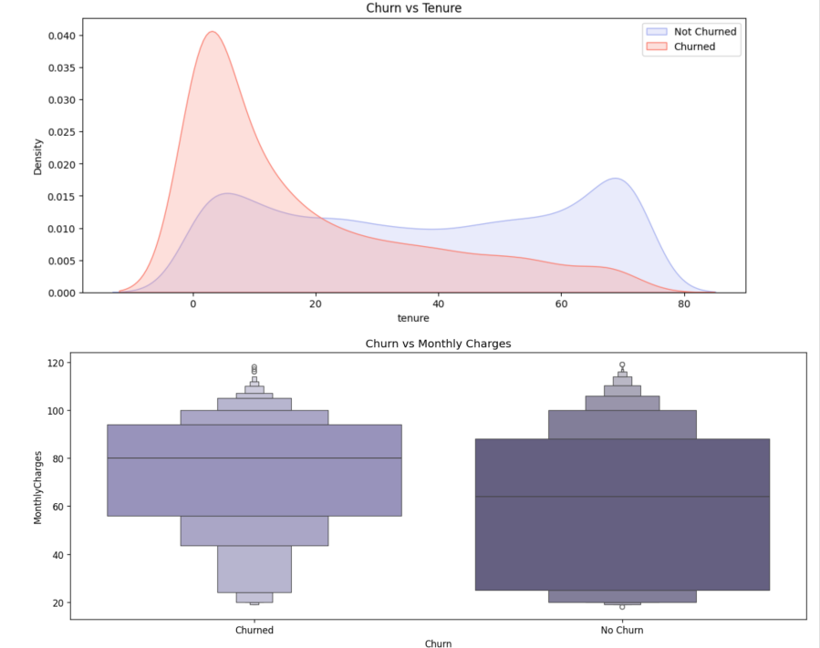

The first chart shows that customers with short tenure are more likely to churn. The red line (churned) peaks at the beginning and then drops. The blue line (not churned) is more stable and increases with longer tenure. The second chart shows that churned customers usually pay higher monthly charges. They tend to leave more when their bills are expensive.